**1993 BioTipp – PRODUCT LIST 2020**

[](http://www.biotipp.com/)

[http://www.algoldiagnostics.fi/files/diagnostics/Logos/Nidacon_logo_rgb_up_to_1240px%20copy.jpg](http://nidacon.com/) [http://www.healthiosxchange.com/public/page/84/0d/0d77_ad57.jpg?c=0c2a](http://www.google.ie/url?sa=i&rct=j&q=&esrc=s&source=images&cd=&cad=rja&uact=8&ved=0CAcQjRxqFQoTCJ-7-rqVlckCFUYmDwodKUAH4w&url=http://www.healthiosxchange.com/page/vedalab-s-a-&psig=AFQjCNHQo_wyn8ZbnYy39rVvW4UadB8fkw&ust=1447770998620795)

[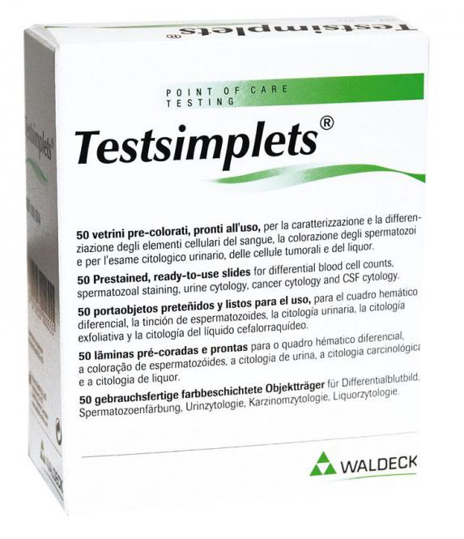](https://www.google.ie/url?sa=i&rct=j&q=&esrc=s&source=images&cd=&cad=rja&uact=8&ved=0ahUKEwj59ebpr-vYAhXMB8AKHdNVCeIQjRwIBw&url=https://www.doccheckshop.de/Praxis/Labor-Diagnostika/Glas-Plastikwaren-und-Zubehoer/Testsimplets.html&psig=AOvVaw1qBlszBlpScJlUpiE1stY2&ust=1516703724827455)[](http://www.google.ie/imgres?imgurl=https://i.ytimg.com/i/q0O5GdaJWKuL0HREUNZCQQ/mq1.jpg?v=54ca2977&imgrefurl=https://www.youtube.com/user/Gynemed&h=240&w=240&tbnid=dTryCU-tvBJ1jM:&docid=izWK4C1Lmc20UM&itg=1&ei=h9JJVrWICoGPPeO7m-gK&tbm=isch&ved=0CCgQMygJMAlqFQoTCPXnm4X_lMkCFYFHDwod490GrQ) [](http://www.google.ie/url?sa=i&rct=j&q=&esrc=s&source=images&cd=&cad=rja&uact=8&ved=0CAcQjRw&url=http://www.inforlablaboratoriais.com.br/produtos/218-placa-cultura-celulas-6-pocos--fundo-chato-com-tampa--marca-tpp.html&ei=tEdLVcTOG-Ge7ga7_YHoAg&psig=AFQjCNF4vuo0pktuoe4Uwd63EQLXdPuJtA&ust=1431083312141590)

[](http://www.google.ie/url?sa=i&rct=j&q=&esrc=s&source=images&cd=&cad=rja&uact=8&ved=0ahUKEwj_gMWgqtjRAhVBBcAKHYcBCVEQjRwIBw&url=http://www.leja.nl/tekst/18/&bvm=bv.144686652,d.ZGg&psig=AFQjCNFqwahevDRjFa5ZPmkGwRhc0SdvOw&ust=1485263024046862) [](https://www.google.com/url?sa=i&rct=j&q=&esrc=s&source=images&cd=&cad=rja&uact=8&ved=2ahUKEwi83MDO69rdAhVFFMAKHcSGDrkQjRx6BAgBEAU&url=https://www.crunchbase.com/organization/nalge-nunc-international&psig=AOvVaw3KVFv5KEmV6T62mBIEDXwx&ust=1538125890976648) [](http://www.google.ie/url?sa=i&rct=j&q=&esrc=s&source=images&cd=&cad=rja&uact=8&ved=0ahUKEwiMuvGYq9jRAhWLKcAKHYyOBUQQjRwIBw&url=http://www.businesswire.com/news/home/20150120005125/en/Eppendorf-Announces-BioFlo%C2%AE-320-Bench-Scale-Bioprocess&bvm=bv.144686652,d.ZGg&psig=AFQjCNHNvOV1Op2WXvGTyvfXGRGLXtk03Q&ust=1485263319355706)[](http://upload.wikimedia.org/wikipedia/de/d/d5/Bbraun.svg) [](http://www.google.ie/url?sa=i&rct=j&q=&esrc=s&source=images&cd=&cad=rja&uact=8&ved=0ahUKEwim4rffqdjRAhXLKcAKHUAKBmAQjRwIBw&url=http://www.prweb.com/releases/Brady_Corporation/Globalmark2/prweb531694.htm&bvm=bv.144686652,d.ZGg&psig=AFQjCNHSg0A64qm6OKqPu8XC3vpUMlHqeQ&ust=1485262923046374) [](http://www.google.ie/url?sa=i&rct=j&q=&esrc=s&source=images&cd=&cad=rja&uact=8&ved=0ahUKEwjvm4n3mdzJAhWFRQ8KHV3hAIYQjRwIBw&url=http://www.fertitechcanada.com/shop/laboratory/oosafe-mea-plasticware/&bvm=bv.109910813,d.ZWU&psig=AFQjCNGq7mB6aMevo8bZODkM2ubC2Oc0gw&ust=1450211753426842)

[](http://www.google.ie/url?sa=i&rct=j&q=&esrc=s&source=images&cd=&cad=rja&uact=8&ved=0CAUQjRxqFQoTCMmH8YSXlckCFcR7Dwod8BcIzg&url=http://www.hawksley.co.uk/downloads/2CELL_McMASTER.pdf&psig=AFQjCNFnXTqMLAZewLq8KYkeSKPnEvNOAA&ust=1447771422670196)    [STERILE DISPOSABLE OBSTETRICAL
VACUUM CUP](http://www.gyneas.com/)

[](http://www.google.ie/imgres?imgurl=http://www.weegschaal.nl/App_Files/FileManager/Afbeeldingen/Content/GilsonLogoEU_1.jpg&imgrefurl=http://www.weegschaal.nl/nieuws/gilson-op-het-instrument-met-kern-balans/&h=184&w=552&tbnid=7ZWv8chGwehKyM:&zoom=1&docid=pfkCJmAz0yUVyM&ei=XS9LVYDxIebm7gaExoGICw&tbm=isch&ved=0CDwQMygWMBY)[](https://www.vitromed.com/)[](http://www.google.ie/url?sa=i&rct=j&q=&esrc=s&source=images&cd=&cad=rja&uact=8&ved=0CAcQjRw&url=http://www.gynetics-services.be/&ei=mUFLVdWeDOaE7gaZ9oGgAw&bvm=bv.92765956,d.ZGU&psig=AFQjCNHI5ldI5mMAA5cXqMEdVZPeqxTDhA&ust=1431081664946356) [](http://www.google.ie/url?sa=i&rct=j&q=&esrc=s&source=images&cd=&cad=rja&uact=8&ved=0CAcQjRxqFQoTCMzroPWUlckCFcUVDwodxGABdw&url=http://www.as1.co.nz/nanoentek/&psig=AFQjCNEf-Ylbe6gf41n01RZ34uqsT-BuTQ&ust=1447765644495131) [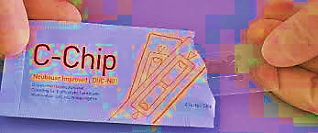](http://www.google.com/url?sa=i&rct=j&q=&esrc=s&source=images&cd=&cad=rja&uact=8&ved=2ahUKEwiyuoH169rdAhWMK8AKHU4rCTwQjRx6BAgBEAQ&url=http://www.biochrom.de/fileadmin/user_upload/service/Tipps_und_Hinweise/englisch/100820_hintergrundinformation_zellen_zaehlen_en.pdf&psig=AOvVaw2tCr7FLScBx9i0x4eo96-r&ust=1538125965107966)[](http://www.google.com/url?sa=i&rct=j&q=&esrc=s&source=images&cd=&cad=rja&uact=8&ved=2ahUKEwiz7amQ69rdAhUaOsAKHe2MBkwQjRx6BAgBEAU&url=http://www.fertitechcanada.com/shop/andrology/cellvision-counting-chambers/&psig=AOvVaw1ejH4zKxHf1pXw8evGb1oc&ust=1538125759591763) [](https://www.google.com/url?sa=i&rct=j&q=&esrc=s&source=images&cd=&cad=rja&uact=8&ved=2ahUKEwiRkKKp6trdAhVCJ8AKHellA2wQjRx6BAgBEAU&url=https://www.slideshare.net/pathologybasics/semen-analysis-29140526&psig=AOvVaw2NbSzwWhj3YjRvaUmiNrI_&ust=1538125525964098) [](http://www.google.com/url?sa=i&rct=j&q=&esrc=s&source=images&cd=&cad=rja&uact=8&ved=2ahUKEwiFjKLq6trdAhXMe8AKHYMJDPoQjRx6BAgBEAU&url=http://www.fertitechcanada.com/brand/cellvu/&psig=AOvVaw2aTBdkeshvAbpOdL8GtKTI&ust=1538125665681012)



***CRYO-BIOTIPP***

***BioTipp (IRL) Ltd. (Est.1993) , Commercial House, 4/5 The Square, Cahir, Co.Tipperary, Ireland E21 CT96 Tel. +35352-7442896 (IRL 052-7442896); e-mail info@biotipp.com;*** [***www.biotipp.com***](http://www.biotipp.com)

[](http://www.biotipp.com/)

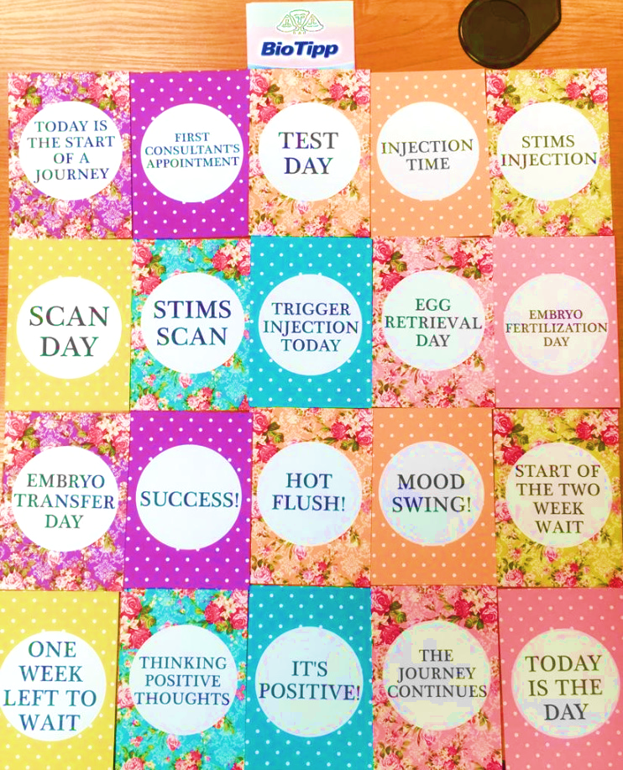

**[](http://www.biotipp.com/)**BioTipp (Est.1993) - PRODUCT LIST 2020

***ANDROLOGY/SEMENOLOGY***

1. Sperm Antibody Tests (MAR)
2. Sperm Activation Medium (+Theophylline)
3. Accu-beads for Quality Control
4. Collagenase
5. Halosperm DNA Fragmentation kit
6. Hypo-osmotic swelling (HOS) test
7. Testsimplets Morphology slides
8. Cell-Vu Morphology Slides
9. Haemocytometers
10. Improved Neubauer Chamber
11. Makler Counting Chamber
12. Disposable Chambers C-CHIP (Imp Neubauer)
13. Post-Vasectomy Counting Slides (NEW)
14. Denominator counters (manual/electronic)
15. HBA Sperm Assay
16. PICSI DISH
17. Laboratory **CE** plastics (see below)
18. Sample collection pots & devices
19. Follicular Fluid Pots
20. Sperm CryoProtec II Freezing Medium
21. Semen collection condoms aka
22. Male Factor Pak condoms
23. IUI/AI catheters
24. Transport cannula system
25. Braun catheters
26. Belaisch Dome
27. Diff-Quik Staining Kit (3x500ml)
28. Sperm Vital Stain (Eosin/Nigrosine)
29. PureSperm 100 stock solution
30. PureSperm 40/80/90 gradients
31. PureSperm Wash/Buffer
32. ReadySwim
33. SpermAssist
34. SpermCatch (PVP alternative)
35. Pro-Insert for IUI
36. SpeediKit for IUI
37. NidOil (Liquid Paraffin)
38. Positive Displacement Pipettes & tips

***LABORATORY PLASTICS***

1. All IVF Plastics
2. IVF 4 Well Dish CE marked
3. IVF 5 Well Dish CE marked
4. IVF ICSI Dish CE marked
5. IVF Petri Dish 35,60,90mm CE marked
6. IVF Centre Well Culture Dish CE marked
7. IVF Petri Dish 90x17 CE marked
8. Tissue culture flasks
9. Petri dishes (treated, coated, irradiated)
10. Serological pipettes 1,2,5,10,25,50ml
11. MicroPestles & Microtubes
12. Pasteur pipettes glass IVF
13. Pipette bulbs/policemen
14. Specimen containers
15. Roller bottles
16. Cell strainers
17. Round bottom tubes 5ml; 14ml
18. Conical tubes 11ml; 15ml; 50ml
19. Transfer Pipettes Plastic 3ml
20. Pipettes digital
21. Pipette tips
22. Syringe Filter units
23. 30ml Universals (Sterilin) **CE marked**
24. Sharps container
25. Specimen containers
26. Kwill Filling Tube

***CRYOPRESERVATION***

1. Freezing straws (embryo, sperm)
2. Vitrification media
3. Vitrification kits
4. VitriBlast Kit (freezing Blastocysts)
5. ThermoBlast Kit (thawing Blastocysts)
6. Goblets & Visotubes
7. Roller Bases
8. Dewars & transporters
9. Storage cassettes
10. Cryo-canes & aluminium cryo-tags
11. CryoSleeves, plastic & aluminium
12. Cryogenic vials CE marked
13. Colour vial closures
14. Cryo lab markers
15. Cryo-straws & plugs
16. Cryofloater
17. Cryo-Scoop (sample retriever)
18. Cryolabels
19. Brady printers & lables
20. Perm/diamond pens
21. Straw filler/micropipette
22. Cryo tongs/grabbers
23. Cryo gloves, aprons
24. Goblets, straws & plugs
25. LN2 level stick /sensors
26. Canes, tabs & canisters
27. Seeding & Handling Forceps

***MICRO-MANIPULATION***

1. ICSI Needles
2. Holding pipettes
3. Transfer pipettes
4. Denudation pipettes
5. The Stripper (Micropipettor)
6. The Stripper for PGD/Cumulus
7. Stripper Tips (75 - 600 microns)
8. PZD pipettes
9. Assisted Hatching pipettes
10. Blastomere biopsy pipettes
11. Polar Body Biopsy pipts
12. Stem Cell ‘Knives’
13. Pasteur pipettes glass

***DIAGNOSTICS***

1. Pregnancy hCG tests
2. Ovulation (LH) tests
3. Anaemia
4. Colorectal & Prostate cancer
5. Menopause (FSH)
6. Andrology stains
7. Urine Multi-Stix (11 parameters)
8. Vaginal pH home test
9. Vaginitis (NEW)
10. Blood Grouping
11. Drugs of Abuse

***CULTURE MEDIA***

1. Vitrification media
2. Oocyte Activation Medium (+Ca ionophore)
3. HTF Medium
4. Immunobeads
5. Liquid Paraffin Oil (NidOil)
6. Hams F10/ DMSO
7. Phos.Buff.Saline (PBS)

***OBSTETRICS & GYNAECOLOGY UROLOGY & COLPOSCOPY***

1. Forceps, scissors, clamps (disposable)(NEW)
2. Umbilical Cord Clamp
3. Amnio-hook
4. Ayre Spatula (wooden)
5. Biopsy Catheter
6. Probe covers (latex or vinyl)
7. Lubrication gel (non-sperm)
8. Fingerstalls for exam.
9. Gauze balls
10. Proctoscope
11. Tweezers (Pozzi/Cherron)
12. Vulva Biopsy Kit
13. Puncture Needle for Amniocentesis
14. Embryo Transfer catheter
15. Trial Transfer catheter
16. Vaginal speculum (disp)
17. Egg collection needles
18. Follicle Aspiration sets
19. Cervical Asp Catheters
20. Cyst Puncture Set
21. Chorion Biopsy Needle
22. PreOvarian Block Needle
23. Colposcopy
24. Min. Invasive Surgery
25. Implant Insertion Kit
26. Termination Kit
27. IUD Insertion Kit
28. IUD Forceps
29. IUI Insemination cath.
30. GIFT catheters
31. ICSI /Holding pipettes
32. Gynae lubrication gel
33. Cervical sampling/brush
34. Difficult transfers cath.
35. Amniocentesis needles
36. Sperm collection needle
37. Chorion biopsy needle
38. Hysterometer
39. Grad. Cervical Canal dilator
40. Frydman catheter
41. TDT Catheter Set
42. Pipelle de Cornier (Endometr. biopsy)
43. Duo Brush (Cervical sampling)
44. Ring pessaries
45. Syringes 1ml-50mls
46. Circumcision Tray - single use (NEW)
47. Umbilical Cord Procedure Kit (NEW)

***DISPOSABLE HYGIENE***

1. Handwear/gloves (70)
2. Aprons/Overalls/masks
3. Vaginal Probe Covers
4. Barrycidal spray
5. 7X Detergent
6. Surgical Drape Packs
7. Hand scrub system

***LIQUID HANDLING***

1. Syringes plastic (2/3 piece)
2. St. Plugged Past Pipette
3. Pipette controller
4. Volumetric glass flasks
5. Glass cylinders; Burettes
6. Graduated pipettes
7. Gilson pipettes
8. Rubber Policemen/bungs
9. Syringe filter
10. Parafilm

***MISCELLANEOUS***

1. XRay detectable Gauze Swabs 10x10 (CE)
2. Suction Pump
3. Heated Stage
4. Warming Plates
5. UltraPure Gas Filters
6. Complete Home Birthing Kit
7. Circumcison Kit
8. ZIVF Air Unit
9. Thermocoins temp indicators
10. Yellow bins
11. Polytack mats

***WOMEN'S HEALTHCARE***

1. Breast Feeding Accessories
2. Home Birthing Kits
3. Emergency Delivery Kits

**_____________________________________________________________________________________**

***BioTipp (IRL) Ltd. (Est.1993) , Commercial House, 4/5 The Square, Cahir, Co.Tipperary, Ireland E21 CT96 Tel. +35352-7442896 (IRL 052-7442896); e-mail info@biotipp.com;*** [***www.biotipp.com***](http://www.biotipp.com)